Site Purpose

The purpose of this website is to give in better detail and help people who will be accommodated have a better idea of the hotel amenities that are within the facilities and to know how it takes cambo the booking procedure, prices and everything regarding accommodation in our line of hotels and lodging. You will also be able to see the locations where we are located so you can plan your trips and find us. All the details you need to know can be found on our website.
Target Audience
The website is open to the public but we specialize more in temple workers, sponsors and their families by providing specialized services and accommodations to meet the needs of those sponsors.

Site Map
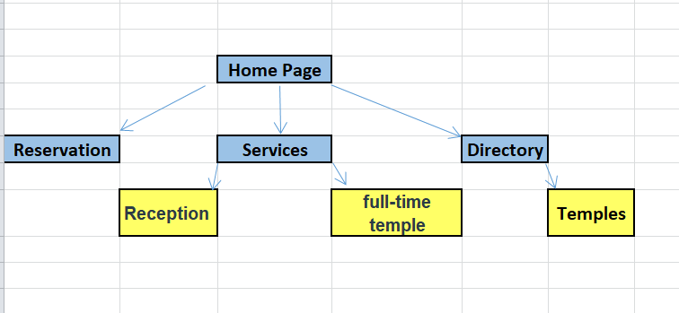
Typography
Heading Font: Helvetica
Paragraph Font: Sans+Serif

Color Scheme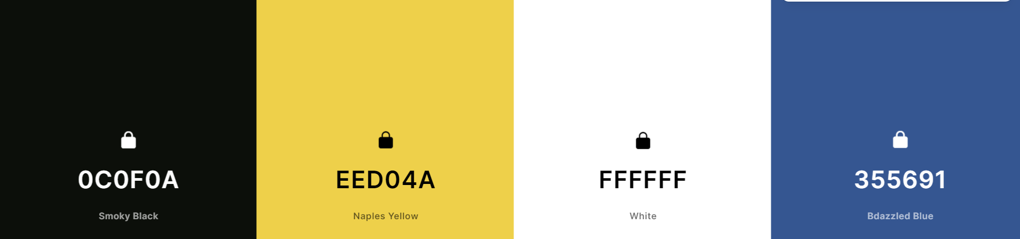

Wireframe Sketches

